Neighborhood Improvement Program

NEIGHBORHOOD ENRICHMENT GRANT PROGRAM

FY26-27 APPLICATION

** Grant changes are effective beginning Fiscal Year 26/27 (July 1, 2026 through June 30, 2027) **

Application submittal period: December 1st, 2025 – February 6th, 2026
Applications that are incomplete or late will not be processed for consideration.

Application Checklist:
A complete application includes this document and the following attachments:

☐ Copy of most recent neighborhood organization’s bank statement
☐ Official vendor quote/estimate for every proposed project expense. All quotes must include vendor letterhead. Quotes must be no more than 30 days old upon application submittal.
☐ Copy of neighborhood organization’s by-laws
☐ Completed latest version of IRS W-9 Form
☐ Map of neighborhood boundaries (recommended)
☐ Organization Meeting Minutes (recommended)
☐ Proof of Permissions/permits (if applicable)

Applicant information:
Fill in the information below. Do not leave anything blank. The Point of Contact will be the main person in communication with NIP about the NEGP, unless otherwise noted. It is REQUIRED that the Point of Contact be someone other than the Neighborhood President/Chair.
Neighborhood Organization | County Council District#

 | neighborhood president | Point of contact
name
Address
city/zip
phone
email

Neighborhood tier funding:
Tier 1 funding is allocated to neighborhood organizations outside of HUD’s of low-to-moderate income (LMI) households. Their funding is maxed at $1,500 per fiscal year. Tier 2 funding is allocated to neighborhood organizations within HUD’s low-to-moderate income (LMI) households. Their funding is maxed at $2,500 per fiscal year. See the Tier Funding Map for reference. Check the tier your organization belongs to below and list your organization’s boundaries:
Tier 1 | ☐ |  |  | Tier 2 | ☐

Neighborhood Boundaries (list all streets in your neighborhood)

The interactive Tier Funding Map can be found here: https://tinyurl.com/TIERMAPNEGP
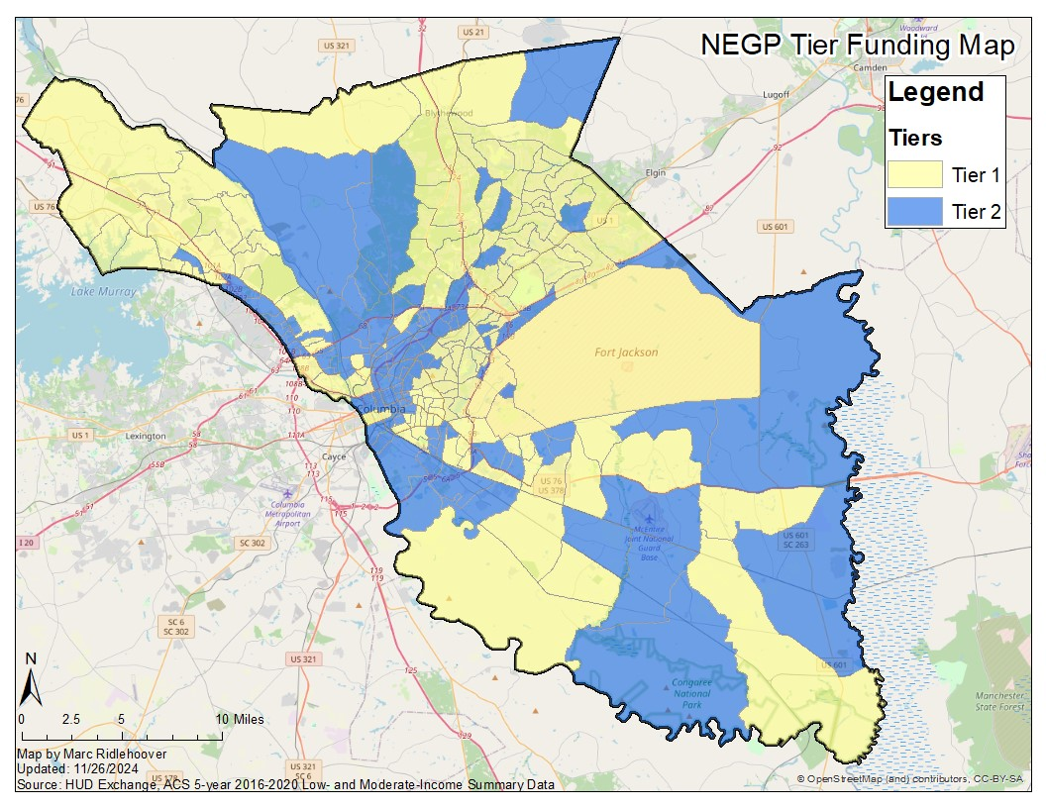

Project Summary:
Enter the name of the project, check the relevant project categories, and answer each question. Provide as many details as possible. See the NEGP Guidelines for project rules and regulations.
Name of Project 1:
PROJECT CATEGORIES:
☐  Neighborhood Beautification | ☐  Safety & Health | ☐  Community Engagement
 | Project description:
Preparation | What timeframe will this project take place? | Begin Date: End Date:
Preparation | Describe the project that your organization is applying for. What do you plan to do? How will you make this happen?
Preparation | Does your neighborhood have a Neighborhood Plan? Describe how this project fits within your Neighborhood Plan Goals.
Preparation | How will this project be maintained or continued?
Preparation | For this project, what does success look like? How will you measure this success?
Impact and Need | Does this project target an underserved population? If so, who?
Impact and Need | How will this project enrich your neighborhood? Why does this project need to happen?
Impact and Need | Describe the enrichment resources or informational materials this project will provide. (ex: medical info, voter registration, etc.)
Neighborhood Participation | How many people will this project serve? Describe the overall demographic. How were they involved in the planning process?
Neighborhood Participation | Is your organization working with any other groups, institutions, local businesses, or municipal departments on this project? If so, who, and how will they be involved?

Project Budget:
List the estimated cost of each expense. Each expense requires an attached quote. The amount you will be awarded equals the total grant amount requested.
Name of Project 1:

EXPENSE | ANTICIPATED COST | GRANT AMOUNT REQUESTED
1.
2.
3.
4.
5.
6.
7.
8.
9.
10.
11.
12.
13.
14.
15.
total:

Project Summary:
Enter the name of the project, check the relevant project categories, and answer each question. Provide as many details as possible. See the NEGP Guidelines for project rules and regulations.
Name of Project 2:
PROJECT CATEGORIES:
☐  Neighborhood Beautification | ☐  Safety & Health | ☐  Community Engagement
 | Project description:
Preparation | What timeframe will this project take place? | Begin Date: End Date:
Preparation | Describe the project that your organization is applying for. What do you plan to do? How will you make this happen?
Preparation | Does your neighborhood have a Neighborhood Plan? Describe how this project fits within your Neighborhood Plan Goals.
Preparation | How will this project be maintained or continued?
Preparation | For this project, what does success look like? How will you measure this success?
Impact and Need | Does this project target an underserved population? If so, who?
Impact and Need | How will this project enrich your neighborhood? Why does this project need to happen?
Impact and Need | Describe the enrichment resources or informational materials this project will provide. (ex: medical info, voter registration, etc.)
Neighborhood Participation | How many people will this project serve? Describe the overall demographic. How were they involved in the planning process?
Neighborhood Participation | Is your organization working with any other groups, institutions, local businesses, or municipal departments on this project? If so, who, and how will they be involved?

Project Budget:
List the estimated cost of each expense. Each expense requires an attached quote. The amount you will be awarded equals the total grant amount requested.
Name of Project 2:

EXPENSE | ANTICIPATED COST | GRANT AMOUNT REQUESTED
1.
2.
3.
4.
5.
6.
7.
8.
9.
10.
11.
12.
13.
14.
15.
total:

Disclosure:
By signing below, I agree that I have completed this application to the best of my ability. I agree that I have read the Neighborhood Enrichment Grant Program Guidelines (NEGP). I understand that it is my responsibility to communicate with the Neighborhood Improvement Program (NIP) with any questions or concerns.
Point of Contact Signature | date
Neighborhood President Signature | Date

Thank you for applying to the Neighborhood Enrichment Grant Program! KEEP A COPY OF THIS APPLICATION FOR YOUR RECORDS. Please send completed applications by email to NIP@richlandcountysc.gov using the subject line “NEGP Application”. Other options include fax, mail, and in-person drop off. Mail received after February 6th, 2026 will be considered late and will be denied.

Mailing Address: | Contact: | Physical Address:
Richland County Community Planning & Development  Neighborhood Improvement Program  P.O. Box 192  Columbia, SC, 29202 | NIP@richlandcountysc.gov  Phone: (803) 576-2190  Fax: (803) 576-2182  Website: https://tinyurl.com/NIPGRANTS | Richland County Community Planning & Development  Neighborhood Improvement Program  2020 Hampton St, Columbia, SC 29204

