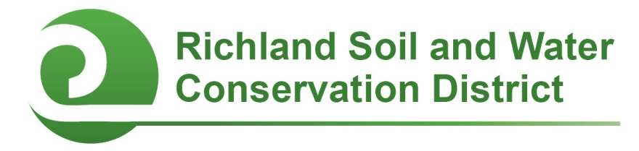
2022-2023 Conservation Education Mini-Grants

Columbia, SC—Richland County public, private, and alternative schools are eligible to apply for up to $1,000 in grant funding to support conservation projects and youth environmental education initiatives through Conservation Education Mini-Grants sponsored by the Richland Soil and Water Conservation District (SWCD). To be eligible for funding, schools must be located in Richland County (including the City of Columbia) or, in the case of schools in Lexington-Richland School District Five, must serve Richland County students.

Mini-Grants may be used to support conservation-related student projects including, but not limited to, outdoor classrooms, school gardens, nature trails, wildlife habitats, rain barrels, composting initiatives, air quality campaigns, litter clean-ups, rain gardens, erosion control, virtual learning opportunities for students, and take-home activities promoting environmental stewardship.

Awards are competitive and proposals will be evaluated on the project’s conservation impact, feasibility, student and community involvement, and educational outcomes. Grants are available in amounts up to $1,000; applicants should design a budget based on what is most appropriate for their project.

Two award cycles are available: applications received by October 3, 2022 will be considered for fall 2022 funding; applications received by February 6, 2023 will be considered for spring 2023 funding. Funding is issued as a reimbursement for project expenses; copies of receipts and a brief final report containing captioned photos of the completed project are required for reimbursement. Project work and the expenditure of funds must be completed by June 15, 2023.

For more information, contact Chanda Cooper at (803) 576-2084 or cooper.chanda@richlandcountysc.gov.

# # #
Conservation Districts are political subdivisions of state government under the local direction of five-member Boards of Commissioners. The Richland Soil and Water Conservation District promotes the wise use and care of natural resources for long-term sustainability.

Contact
Richland Soil and Water Conservation District
2020 Hampton Street, Room 3063A
Columbia, SC 29204
Phone (803) 576-2084
Fax (803) 576-2088
E-mail soilandwater@richlandcountysc.gov
Facebook www.facebook.com/rswcd

2022-2023 Conservation Education Mini-Grant Application

Please respond to the following questions. Expand response areas and attach additional pages as necessary.

Applicant’s Name: ____________________________Title/Position:______________________________

Applicant’s E-mail: ____________________________Applicant’s Phone: __________________________

School: _______________________________________________________________________________

School Address: ________________________________________________________________________

Principal’s Name: ______________________________Principal’s E-mail: _________________________

- Project Title:

- Describe the proposed project and how it will promote natural resource conservation and education.

- I am applying for
___ $250 ___$500 ___$750 ___ $1,000

- Project Budget (add additional rows as necessary):
Item | Unit Cost ($) | Quantity | Total Cost ($)
Total ($)

- If your proposed project will cost more than $1,000 (the maximum amount of the mini-grant), how will the rest of the project be funded?

- Project timeline: Describe your project’s timeline.

- Student Involvement:
  - How many students will be involved with this project? List by grade.
  - How will students be involved with this project?

- Collaboration: Describe if and how other faculty members, staff, parents, project mentors, or community volunteers will be involved with the project.

- Educational Outcomes: How will this project enhance student learning? If appropriate, include any academic standards this project will be used to address.

- Optional Supporting Materials: You are welcome but not required to submit captioned photographs, letters of support, or other materials demonstrating why your project deserves to receive a Conservation Education Mini-Grant. (Tip: At least one letter of support and at least one photo are recommended. These may be submitted, along with the application, via US Mail, e-mail, or fax per the instructions below.)

- Administrator certification: A school administrator (principal or headmaster) must certify that they are aware of this grant proposal, support the proposed project, and, if the project is selected for funding, will allow the project to be installed or completed on school property. Please have your school administrator either sign on the line below OR submit a separate certification (via US Mail, e-mail, or fax per the instructions below) acknowledging their support for this project.

_______________________________________________ _______________________
Principal’s Signature Date

Submit your application and any optional supporting materials by US Mail, e-mail, or fax, to:

Richland Soil and Water Conservation District
2020 Hampton Street, Room 3063A
Columbia, SC 29204
Phone: (803) 576-2084
Fax: (803) 576-2088
E-mail: cooper.chanda@richlandcountysc.gov

Application Deadlines:
October 3, 2022 and February 6, 2023

