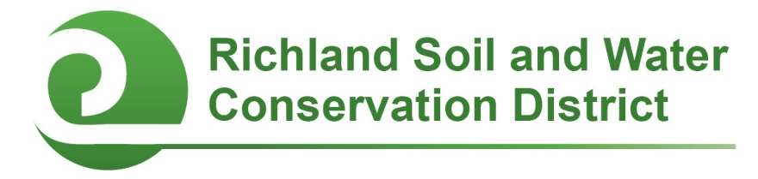
2020 Richland County Conservation Teacher of the Year
Nomination Form

Eligibility: Teachers at any public, private, or alternative school in Richland County are eligible to receive this award. Prior winners are eligible to receive the award a second time. Self-nominations and nominations from individuals or groups who are familiar with the teacher’s activities related to this award are all acceptable. Nominations must be received by February 3, 2020.

Teacher’s name:

Teacher’s position (grade and subject):

Teacher’s e-mail address: Teacher’s phone:

School: School phone:

Nominator’s name and position (if not a self-nomination):

Nominator’s e-mail address: Nominator’s phone:

Justification (please respond on a separate page or pages):
- Narrative: Describe the nominee’s involvement in school conservation projects and environmental education initiatives. What projects does the nominee lead at school? What student learning outcomes result from these projects? What characteristics make this nominee successful at launching and leading environmental initiatives on campus? How does this nominee exhibit leadership or provide support for other teachers?
- List any grants, awards, or other forms of recognition this teacher has earned for his/her conservation efforts.
- List conservation-related professional development opportunities the nominee has attended or completed (academic degrees or certificates, courses, workshops, trainings, etc.).
- List conservation-related professional development opportunities the nominee has provided for other educators (presenting at conferences, facilitating workshops, etc.).
- List conservation related organizations the nominee belongs to or community conservation efforts the nominee is involved in (anything outside of school/not covered above).

Optional Supporting Materials: You are welcome but not required to submit photographs (with captions), letters of support, or other materials demonstrating why this teacher deserves to be the Richland County Conservation Teacher of the Year.

Send nomination form and any optional supporting materials to:

Richland Soil and Water Conservation District
2020 Hampton Street, Room 3063A
Columbia, SC 29204
Fax: (803) 576-2088
E-mail: cooper.chanda@richlandcountysc.gov
Phone: (803) 576-2080

Nominations must be postmarked or submitted electronically by February 3, 2020.

