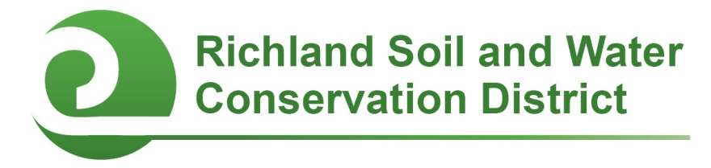
2018-2019 Conservation Education Mini-Grants

Columbia, SC—Faculty and staff members of public, private, and alternative schools in Richland County are eligible to apply for grants in the amounts of $500 or $1,000 to support campus conservation projects and youth environmental education initiatives through Conservation Education Mini-Grants sponsored by the Richland Soil and Water Conservation District (SWCD).

All schools located in Richland County (including the City of Columbia) are eligible to compete for Conservation Education Mini-Grants. Mini-Grants may be used to support conservation-related student projects including, but not limited to, outdoor classrooms, school gardens, nature trails, wildlife habitats, rain barrels, composting initiatives, air quality campaigns, litter clean-ups, rain gardens, erosion control, and stream bank restoration. Awards are competitive and proposals will be evaluated on the project’s conservation impact, feasibility, student and community involvement, and educational outcomes. Grants are available in amounts of $500 or $1,000; applicants should design a budget based on what is most appropriate for their project.

Two award cycles are available: applications received by September 28, 2018 will be considered for fall 2018 funding; applications received by February 1, 2019 will be considered for spring 2019 funding. Funding is issued as a reimbursement for project expenses; copies of receipts and a brief final report containing photos of the completed project are required for reimbursement. Project work and the expenditure of funds must be completed by June 1, 2019. Funding for these awards is provided by the Richland SWCD. For more information, contact Chanda Cooper at (803) 576-2084 or cooper.chanda@richlandcountysc.gov.

# # #
Conservation Districts are political subdivisions of state government under the local direction of five-member Boards of Commissioners. The Richland Soil and Water Conservation District promotes the wise use and care of natural resources for long-term sustainability.

Contact
Richland Soil and Water Conservation District
2020 Hampton Street, Room 3063A
Columbia, SC 29204
Phone (803) 576-2080
Fax (803) 576-2088
E-mail soilandwater@rcgov.us
Facebook www.facebook.com/rswcd

2018-2019 Conservation Education Mini-Grant Application

Please respond to the following questions. Expand response areas and attach additional pages as necessary.

Applicant’s Name: _________________________Title/Position:_________________________

Applicant’s E-mail: ________________________Applicant’s Phone: _____________________

School: _______________________________________________________________________

School Address: ________________________________________________________________

Principal’s Name: _________________________Principal’s E-mail: ______________________

- Project Title:

- Describe the proposed project and how it will promote natural resource conservation and education.

- I am applying for
___ $500
___ $1,000

- Project Budget (add additional rows as necessary):
Item | Unit Cost ($) | Quantity | Cost ($)
Total ($)

- Funding: If your project will cost more than $500 or $1000 (the maximum amount of the mini-grants), how will the rest of the project be funded?

- Project timeline: Describe your project’s timeline.

- Student Involvement:
  - How many students will be involved with this project? List by grade.

  - How will students be involved with this project?

- Collaboration: Describe if and how other faculty members, staff, parents, project mentors, or community volunteers will be involved with the project.

- Educational Outcomes: How will this project enhance student learning? If appropriate, include any state or local academic standards this project will be used to address.

- Optional Supporting Materials: You are welcome but not required to submit photographs with captions, letters of support, or other materials demonstrating why your project deserves to receive a Conservation Education Mini-Grant.

- Administrator certification: A school administrator (principal or headmaster) must certify that they agree to allow the proposed project to be completed or installed on campus. Please have your school administrator either sign on the line below OR submit a separate certification in writing (fax or e-mail is acceptable) acknowledging their support for this project.

_______________________________________________ _______________________
Principal’s Signature Date

Submit your application and any optional supporting materials by US Mail, E-mail, fax, or hand delivery to:

Richland Soil and Water Conservation District
2020 Hampton Street, Room 3063A
Columbia, SC 29204
Phone: (803) 576-2080
Fax: (803) 576-2088
E-mail: cooperc@rcgov.us

Application Deadlines:
September 28, 2018 and February 1, 2019

